EXPERIMENT- 23
Perform Sharpening of Image using Unsharp Masking
Aim
To write a Python code to sharpen an image using unsharp masking technique in OpenCV for enhancing image details and improving visual quality.
Input Image
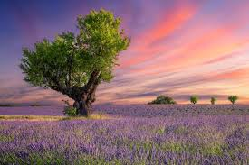
Code
import cv2
import numpy as np
from google.colab.patches import cv2_imshow
from google.colab import files
uploaded=files.upload()
image_path=list(uploaded.keys())[0]
image=cv2.imread(image_path)
if image is None:
print("Error: Image not found")
else:
image_float=np.float32(image)
blur=cv2.GaussianBlur(image_float,(0,0),5)
unsharp_mask=cv2.addWeighted(image_float,2.5,blur,-1.5,0)
sharpened_image=cv2.convertScaleAbs(unsharp_mask)
print("Original Image")
cv2_imshow(image)
print("Unsharp Masked Image")
cv2_imshow(sharpened_image)
Output Image
Unsharp Masked Image
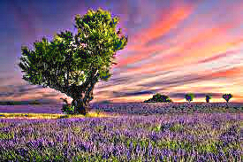
Result
Thus, the image was successfully sharpened using unsharp masking technique in OpenCV.

